HNLP Project: Towards interpretable readmission prediction using DLA on MIMIC-IV dataset
Jasleen Gandhi, Jumanh Atoum, Zachary Silver

Introduction

Hospital readmissions, particularly those occurring within 30 days of discharge, remain a persistent challenge in modern healthcare systems. Unplanned readmissions are associated with increased patient morbidity and mortality, substantial financial burden, and fragmented care transitions. In the United States, readmission rates are publicly reported and financially penalized under the Hospital Readmissions Reduction Program, emphasizing the national priority placed on reducing avoidable hospital returns. Despite ongoing quality improvement initiatives, accurately identifying patients at high risk for readmission before discharge remains an unresolved problem.

Natural language processing NLP approaches have demonstrated improved performance in predicting readmission compared to models that rely solely on traditional structured variables. Nevertheless, many existing prediction models continue to depend heavily on structured electronic health record EHR data such as demographics, laboratory values, and comorbidity indices, which while informative, fail to capture the contextual and semantic nuances embedded in clinical narratives. To facilitate research in this domain while preserving patient privacy, large scale deidentified datasets such as MIMIC-IV have been developed. This publicly available in hospital dataset contains detailed clinical information from patients admitted to intensive care units and emergency departments and was curated to balance data accessibility with patient confidentiality. The availability of such datasets is essential for advancing clinical predictive systems and improving patient care, as readmission prediction remains a persistent challenge despite advances in modeling techniques. Importantly, the richness of data within MIMIC IV, including both structured and unstructured documentation, enables investigation of diverse outcomes such as hospital readmission, emergency department readmission, or absence of return to care.

Accurate prediction of emergency department and hospital readmission is essential to understand the mechanisms underlying clinical deterioration and failed care transitions. Although many models rely primarily on structured electronic health record data such as demographics, laboratory values, diagnosis codes, and prior utilization, these variables often lack the contextual information necessary to explain why a patient returns. In contrast, discharge summaries provide a clinically rich synthesis of hospitalization, incorporating provider reasoning, complications, treatment response, residual instability at discharge, follow up planning, and social and behavioral determinants of health. As a semantically dense representation of the patient’s transition from acute illness to recovery, discharge notes encode both objective clinical status and subjective assessments of readiness for discharge.

Advances in natural language processing and deep learning have shown that incorporating discharge narratives significantly improves prediction of 30 day readmission. Studies using MIMIC-III and MIMIC-IV from Beth Israel Deaconess Medical Center demonstrate that models leveraging clinical text outperform those trained solely on structured variables, with recurrent, convolutional, and transformer-based architectures capturing meaningful semantic risk patterns. However, most existing approaches treat readmission as a single outcome without distinguishing between hospital readmission after discharge to the community and ICU readmission following transfer. This distinction is mechanistically important. Thirty-day hospital readmission is often driven by care transitions, outpatient access, and social complexity, whereas ICU readmission, frequently occurring within 48 to 72 hours, reflects unresolved physiological instability and is strongly associated with higher in-hospital mortality and prolonged length of stay. Conflating these outcomes may obscure distinct risk pathways and dilute clinically relevant semantic signals embedded in discharge documentation, limiting both interpretability and clinical utility.

This is kind of the big picture, not limited to the result we have, but incorporates the long-term goals for this project.
In this work, we use MIMIC-IV to predict 30-day post-discharge outcomes by integrating all clinical notes with structured-electronic health record (EHR) data. We model whether patients experience no return or hospital readmission, and apply Differential Language Analysis to identify linguistic patterns associated with each outcome. This approach combines multimodal prediction with interpretable language analysis to better understand how clinical documentation reflects readmission and acuity risk.

Dataset

We use the Medical Information Mart for Intensive Care (MIMIC-IV) database, a large de-identified electronic health record EHR dataset containing detailed emergency department visits and hospital admissions from Beth Israel Deaconess Medical Center between 2008 - 2022. Data was obtained from the MIMIC-IV (v3.2.1) and the associated MIMIC-IV-ED (v2.2). MIMIC-IV includes both structured clinical data, such as demographics, admission characteristics, diagnoses, laboratory results, and unstructured free-text clinical notes. For this study, the following tables were used: hospital admissions, emergency department (ED) stays, patient demographics, diagnoses using International Classification of Diseases (ICD), procedures (ICD), Current Procedural Terminology (CPT)/Healthcare Common Procedure Coding System (HCPCS) events, and discharge notes. This design enables a multimodal fusion framework that integrates linguistic signals from clinical documentation with quantitative measures of patient severity and comorbidity burden. All data processing and analysis were conducted in Python using pandas and NumPy. Machine learning modeling was performed using scikit-learn.

Method

The Methods section is organized into two primary components: tokenization and deep learning analysis DLA metrics. For each component, we provide a detailed description of the approach and justify its suitability for modeling the clinical text and outcomes within the MIMIC-IV dataset.

Pre-processing and Tokenization
Hospital admissions and ED stays were extracted and standardized by renaming timestamp variables to unified fields (admit_time, discharge_time). A visit_type variable was created to distinguish between inpatient hospitalizations (“hospital”) and ED encounters (“emergency dept”).
The two datasets were concatenated into a unified visit-level table. Visits were sorted chronologically within each patient (subject_id), and a sequential visit_number was assigned using a cumulative count per patient.
Only essential visit-level fields were retained: patient identifier, hospital admission ID (hadm_id), ED stay ID (stay_id, when applicable), visit type, admission time, and discharge time.
Visit-level data were merged with patient demographics, including sex (gender), anchor age, anchor year, and anchor year group. Age at each visit was computed using the following formula:
$$\text{Age at visit}=\text{anchor_age}+(\text{visit year}-\text{anchor_year})$$
If visit timestamps were missing, age was assigned as missing. Length of stay (LOS) in days was calculated as the difference between discharge and admission times divided by 24 hours. Admission hour (in fractional hours) was also extracted.
For hospital admissions, ICD diagnosis codes were grouped by hadm_id and aggregated into lists and comma-separated summaries. The total number of ICD codes per visit (icd_count) was computed as a proxy for diagnostic complexity.
Procedure codes were similarly grouped and counted. HCPCS/CPT codes were aggregated by hospital admission and summarized as counts (cpt_count). For ED encounters, ICD and CPT fields were initialized as empty lists (given limited structured ED coding in this workflow).
Discharge notes were grouped by patient and hospital admission, concatenating all note text per admission into a single discharge_notes field. For hospital encounters, the number of discharge summaries per visit was calculated. ED report counts were similarly derived for ED visits when applicable.

Machine Learning

A supervised learning framework will be implemented using scikit-learn to model for the prediction of time until next visit (regression task).
The dataset was split into training and test sets using train_test_split. Feature preprocessing included optional scaling using StandardScaler.
For classification, a RandomForestClassifier was used. For regression, a RandomForestRegressor was applied. Hyperparameter tuning was performed using GridSearchCV.
Model performance was evaluated using:
Accuracy and classification report (precision, recall, F1-score) for the classifier,
Mean Absolute Error (MAE) and R² for the regression model.
Differential Language Analysis Metrics
Differential language patterns were quantified using a smoothed log-odds ratio with informative Dirichlet prior to compare lexical feature distributions across outcome groups. Primary contrasts included: (1) readmission vs. no return within 30 days and (2) ICU-return vs. non-ICU readmission. The log-odds framework is well-suited for sparse, high-dimensional clinical language and provides interpretable effect direction, indicating whether a word or phrase is overrepresented in one outcome group relative to another.

To further account for structured confounders, a secondary analysis employed regularized logistic regression incorporating both text-derived features (TF-IDF unigrams/bigrams) and structured covariates. This allowed estimation of language associations with readmission probability while controlling for demographic and clinical severity variables.
We need to add how we will account for statistical significance

Preliminary Results:
The dataset has 302861 total patients. The total ED visit records were 425087 and hospital visit records were 546028. That gives us 971,141 visit datapoints to use for this project. The aggregate number of visits had a statistical mean of 3.206 visits per subject id and a median of 2 visits.
[Table 1 write up] We analyzed the distribution of ICD codes within our cohort to identify the most prevalent diagnoses. First, all entries with missing ICD codes were excluded. Frequencies for each ICD code were then calculated by counting the number of occurrences across all patient records. The relative frequency was expressed as a percentage of the total number of recorded ICD codes. To improve interpretability, ICD codes were mapped to their corresponding disease descriptions using a reference ICD dictionary. The top 10 most frequent ICD codes were identified based on absolute counts and merged with their clinical descriptions.
Table 1: The table contains the most frequent icd diagnosis code, the number of occurrences of that icd in our data, percentage compared to all patients, and the corresponding disease description.
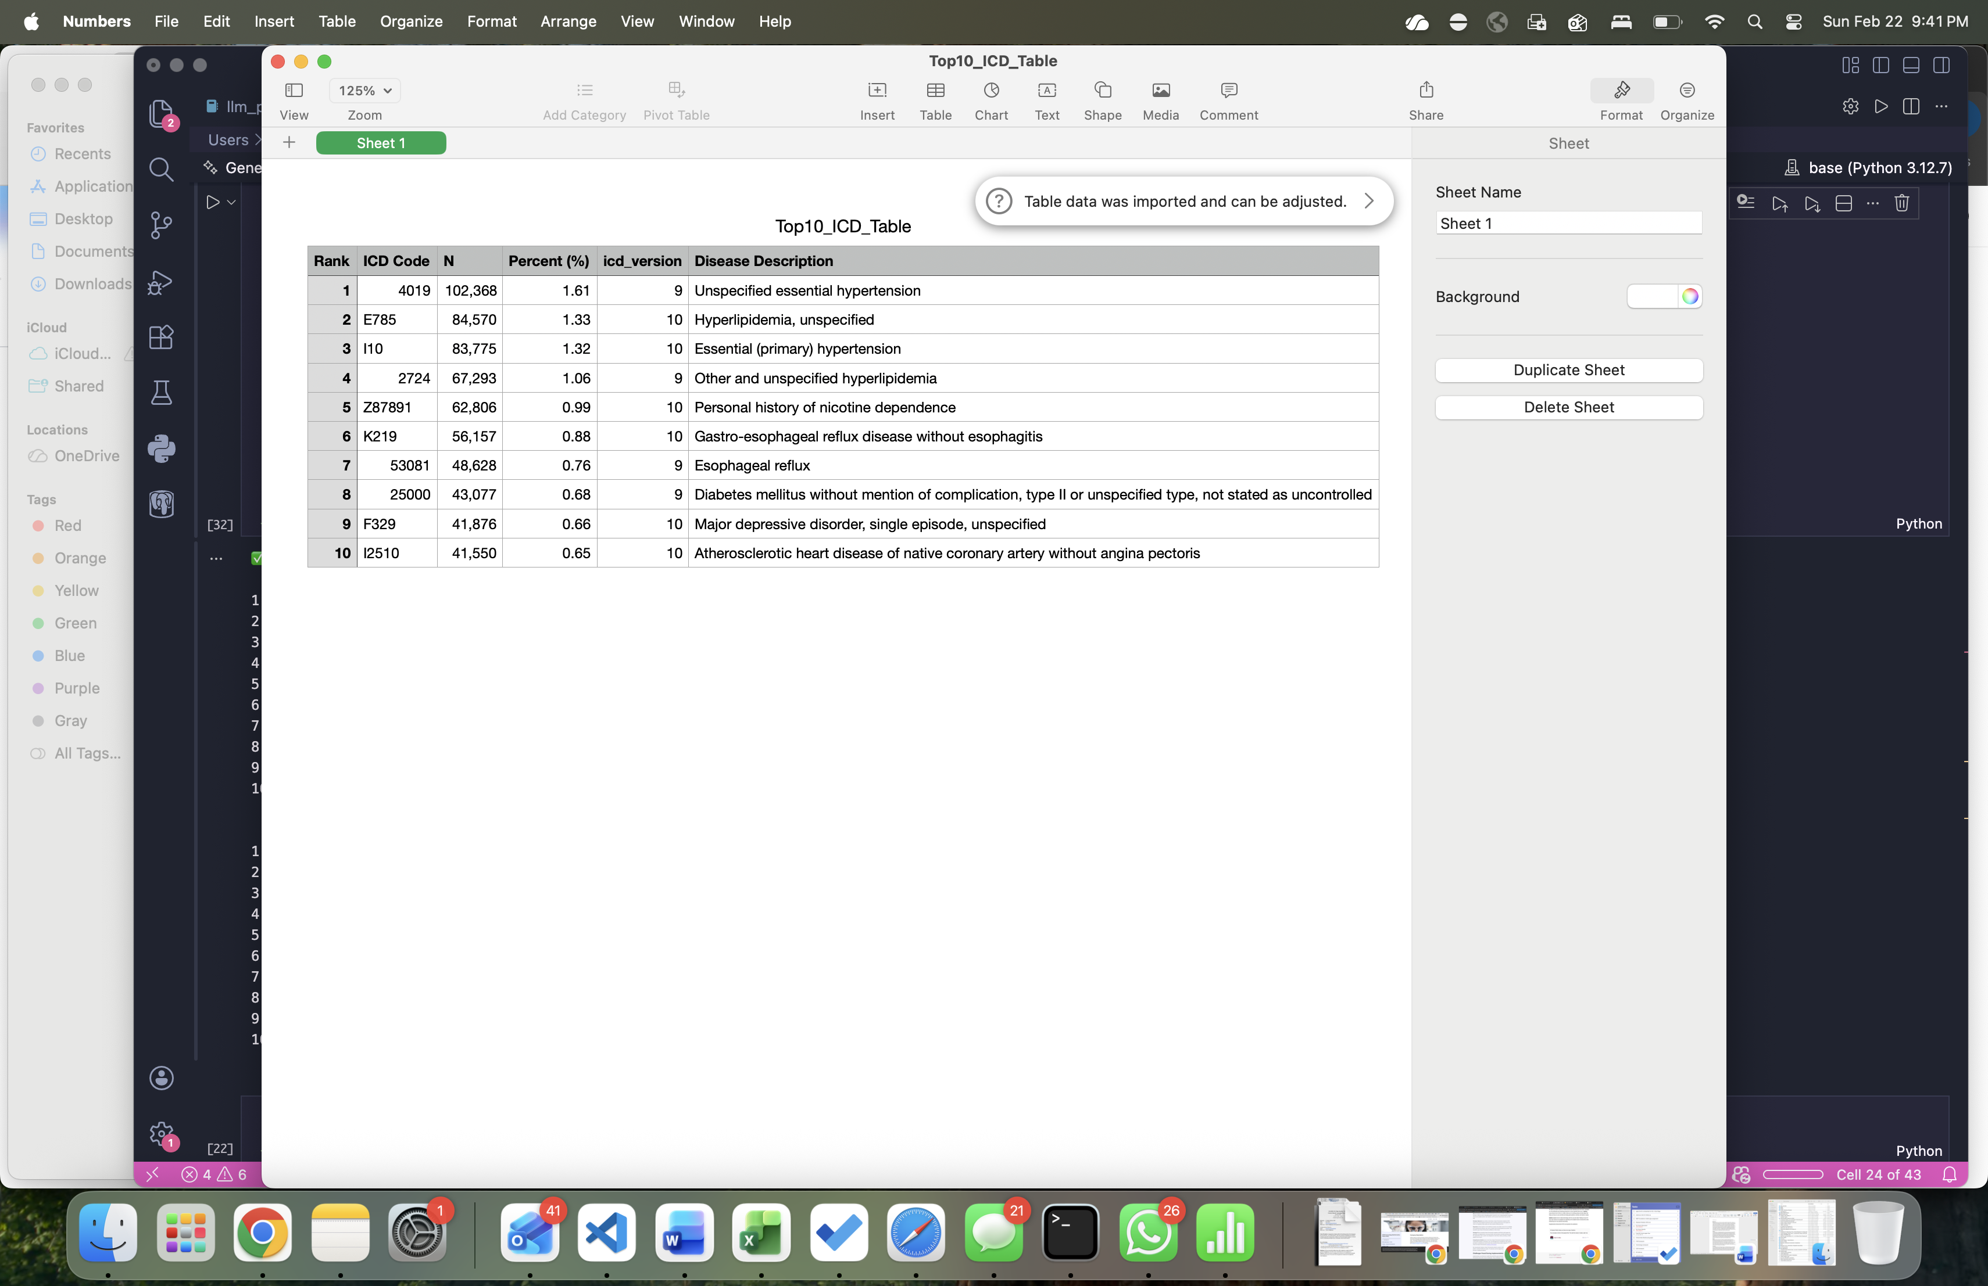

Bibliography
[APA format]
Johnson, A., Bulgarelli, L., Pollard, T., Gow, B., Moody, B., Horng, S., Celi, L. A., & Mark, R. (2024). MIMIC-IV (version 3.1). PhysioNet. RRID:SCR_007345. https://doi.org/10.13026/kpb9-mt58

